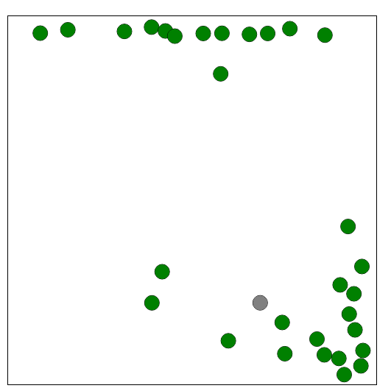
In this first attempt (timeBetweenMatings = 100), the balls grouped into two groups. They did not avoid the grey ball much at all (apart from through avoiding the centre of the box). Instead they crowded onto sides or corners, where they could breed quickly. When the grey ball came and wiped half of them out, there was enough of the rest to get numbers back up quickly.

An interesting point is that they segregated into two races, and although occasionally a mix would be bred, in general they never got near each other.

